Project: NFT auction

Executive Summary: NFT artwork auction within limited timeframe and transact via blockchain/tokens. (option: Open market and allow public to upload artwork/digital format asset for auction, charging auction transaction fee).

Steps:

1. Data compile/gathering: set up DB (SQL or dataframe)? (Loc)
2. Blockchain: Deploy contract, mint token, btc/eth->token

transfer tokens/eth, balance check, (Leigh)

(c ) Python: transaction ledger, balance tracking, table for bidder rank

(d) Streamlit: formatting, input gathering, table/dashboard display, timer (Eunice)

(e) Presentation Preparation (Amine)

https://video.search.yahoo.com/search/video?fr=mcafee&ei=UTF-8&p=streamlit+timer&type=E211US105G0#id=1&vid=197c06593c422568e52526c44125c8d8&action=click

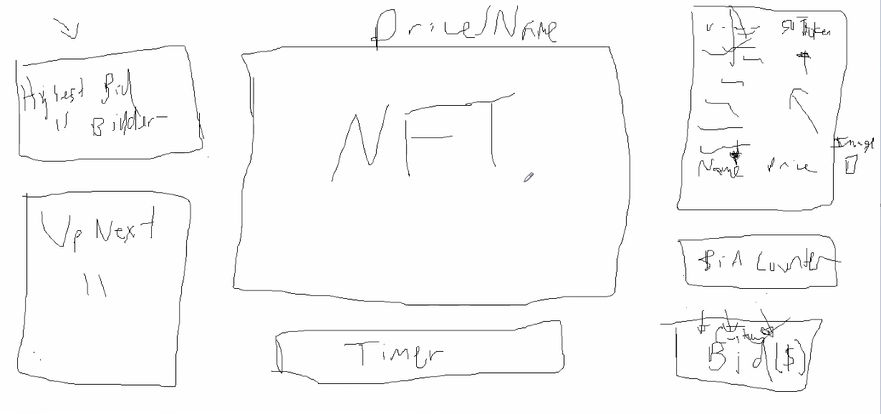

GitHub Repo: <https://github.com/EuniceH/NFT_auction.git>